**SARVANGASANA FAMILY ALTERNATIVES**

**‘’Be there Quiet for a while’ April 8, 2020 by Ann Kilbertus drawings by Lauren Cox**

Can you hear the voice of your teacher (inner or outer): “It’s time for shoulder stand or something from the sarvangasana family”. In almost every sequence of practice, this category of asanas is present. Light on Yoga by BKS Iyengar describe pages of its benefits. It is often practiced at the end of a sequence before a series of quietening poses and/or savasana. If a person can be in headstand, shoulderstand is always taken after headstand for equal or longer duration. Any family member or variation in the sarvangasana series (clearly laid out in Light on Yoga) helps the practitioner develop the vital area on the sides of the chest which was so clearly described in the last issue of e news. In these days of quarantine and self isolation taking time to be with yourself and learning to hold a variation of sarvangasana may bring with it many effects. Regular practice of sarvangasana and its variations helps the practitioner develop the subtle qualities of patience and emotional stability. The systems of the body are pacified and the nerves are soothed. The drawings below may help the practitioner in finding ways to practice one or many versions of sarvangasana on a regular basis. If full shoulderstand or chair shoulderstand are challenging for you, there are other family members in the sarvangasana series. Find your way inward to learn more about this family slowly and safely with just a few of the suggestions below:

**1. Chatush Padasana**- active study to investigate how the arms and legs cooperate to lift the chest area more, repeat 2-3 times, and keep breathing throughout

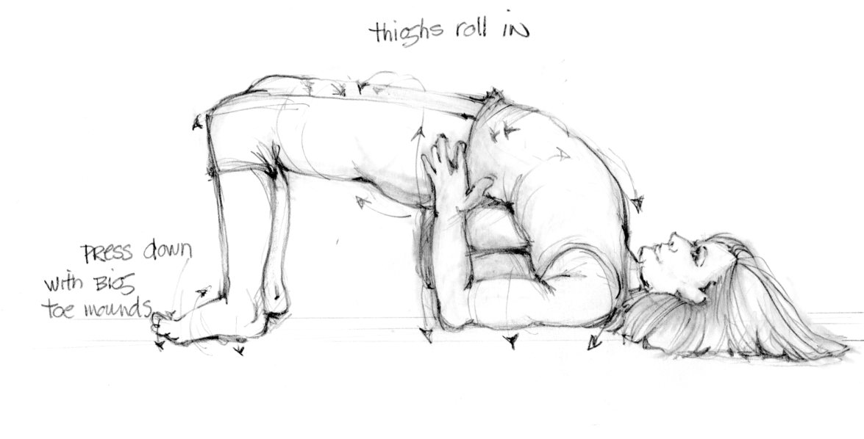

**2a. Bent Knee and 2b. Straight Leg Setu Bandha** – sustain the actions of the legs and position the shoulders well to open the chest-good option for menstruation and general fatigue-hold ( 3-10 minutes). Raise the feet a little higher or bend the knees if the back is sore.

**2a.**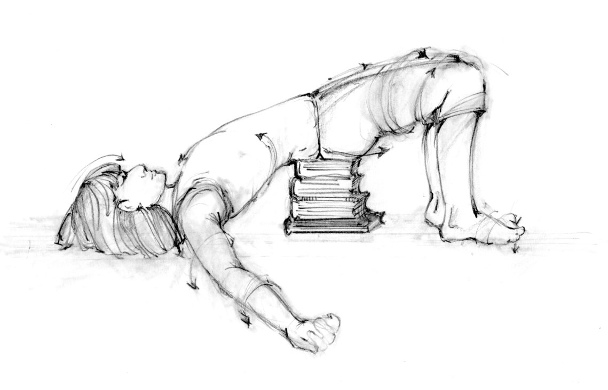

**2b.**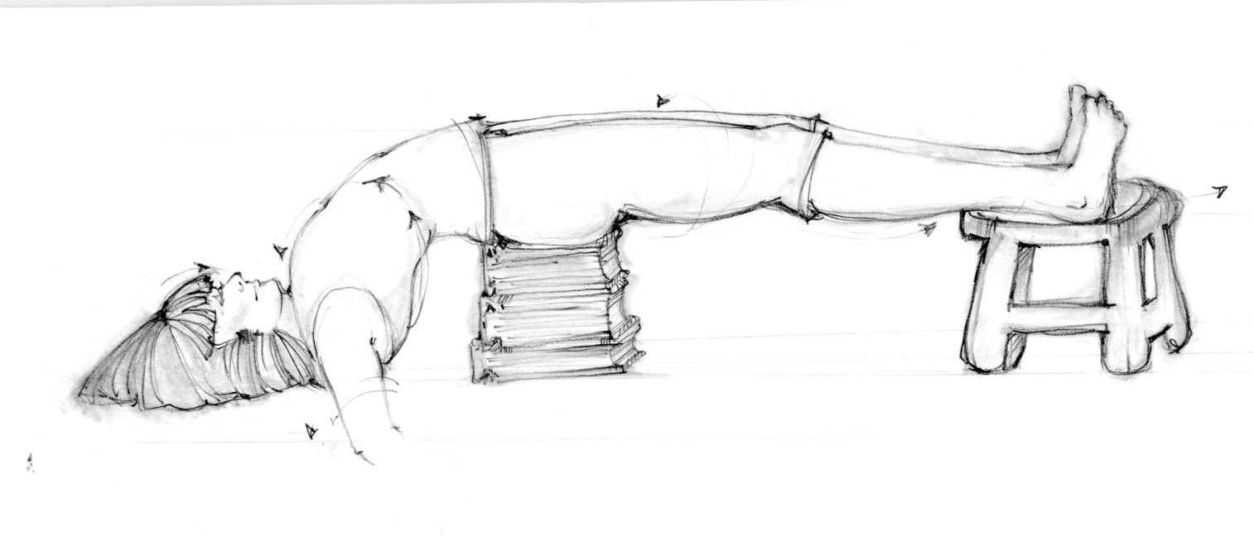

**3. Bent knee Viparita Karani**- pacify the legs and abdomen while keeping the chest well open and shoulders down (3-10 minutes).

You’re on the right track if in a supported version of the asana the mind begins to settle down. Sometimes a small adjustment in the body or to the placement of a prop can make a big difference. Learn your own work. What actions need to be created and sustained to bring you to a state of quietude, a state of reflection, a state of not looking here and there? Then, to quote Geeta Iyengar “be there quiet for a while”.

